\

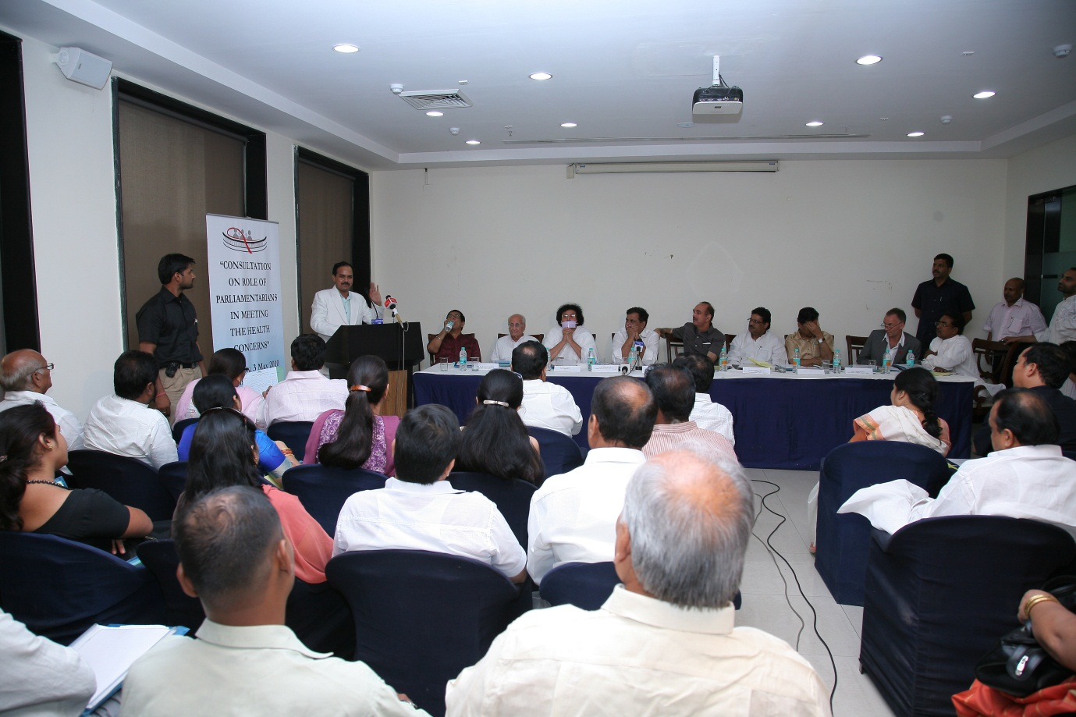

The Parliamentarians' Forum on HIV/AIDS in meeting at Constitution Club, Delhi

Sri. Oscar Fernandes MP & President FPA, Dr. Lajpatrai Mehra, Acharya Dr. Lokesh Muni, Sh. Shrikant Jaina Cabinet Minister,

Sri. Gulam Nabi Azad Minister for Health & Family Welfare, Sh. Kirty Azad MP & Vice President FPA,

Sri. P. S. Ghatowar MP, Dr. Sangay Thinley Acting WHO Country Representative to India

And Parliamentarians

